How to Use the Plan Room (From a Public Login) V4.5+
Note:
If you encounter a problem when accessing or using the Spitfire Plan Room, check first with your own IT department or help desk. The problem may be caused by something on your workstation.
If IT can’t fix the problem, contact _________________________________ and explain the nature of your problem in detail.

The Spitfire Plan Room lists documents that contain bidding plans, drawings, specifications, addendums, and other project-related information.

To Access the Plan Room
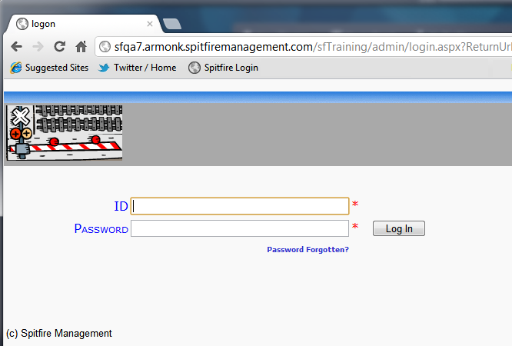
- Go to the URL provided to you. The Login in screen will appear.
- Type the ID provided in the ID field and the password in the Password field.
- Click the .The Plan Room will appear:

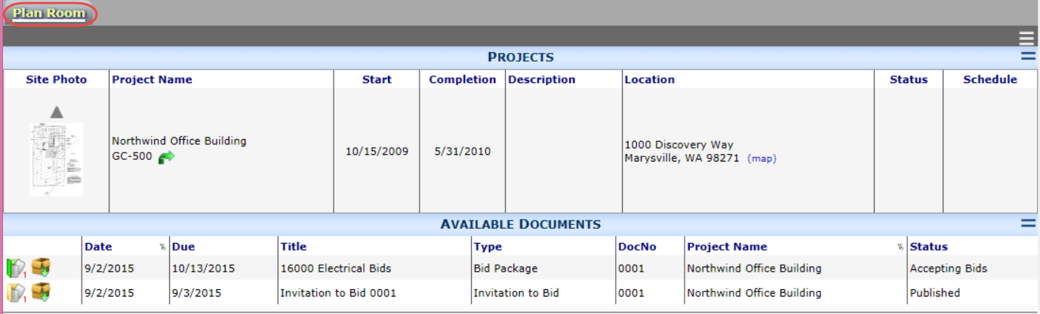

To Select a Project
You may have access to more than one project in the Plan Room. All accessible projects are listed at the top of the dashboard.
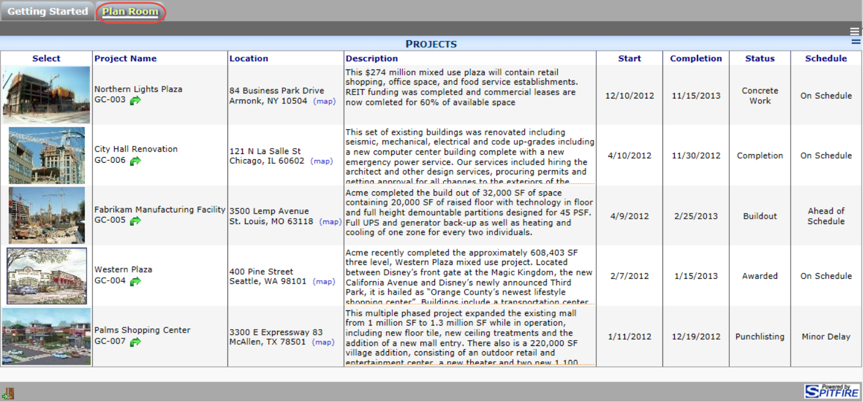

- Click on the photo of the project you want to select
-or-
Click on the Project Name of the project you want to select.
The selected project will remain at the top and available documents for that project will be listed below it, for example:
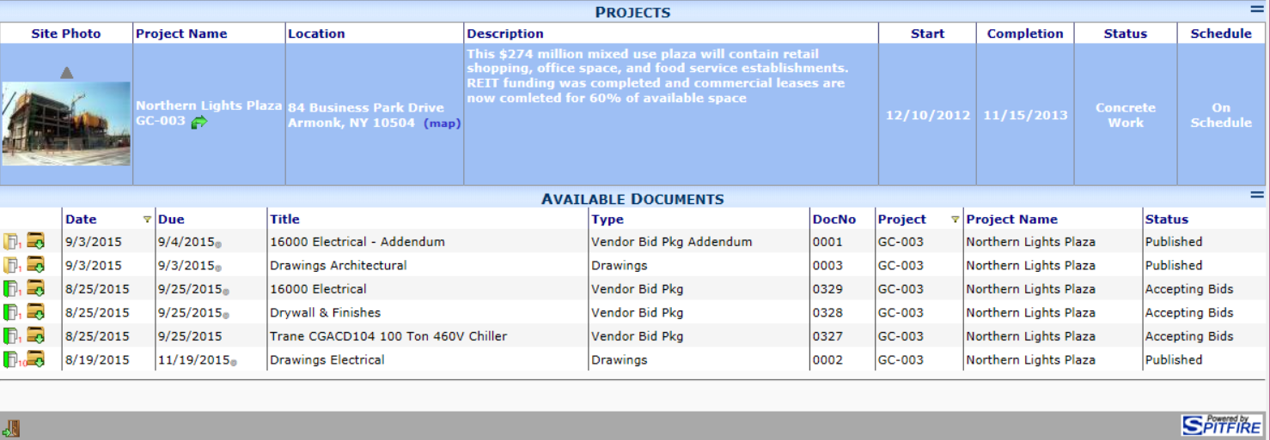
- To return to the Project List, click above the photo.

To Download Files to Your Computer
You can download all attached files onto your computer. The download icon appears on the Plan Room document list. The download function creates a compressed .zip file that contains all the document’s attached files.
- Click from the document list:
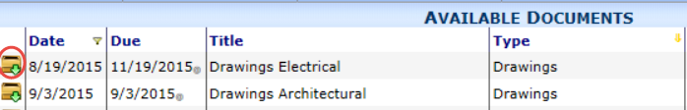
A dialog box will appear.
  - Select to see the folders within the .zip file saved on a default location on your computer/network. You can open each folder to find files.
  - Select to indicate a different location for the .zip file.

To Log Off and End Your Session
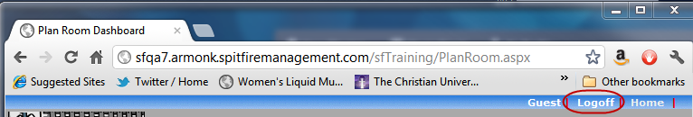
- Click on the Logoff link:

