How to Use the Plan Room (From a Vendor Login) V4.6
The Spitfire Plan Room lists documents that contain bidding plans, drawings, specifications, addendums, and other project-related information.
When a company provides you with information about its Spitfire Plan Room, go to the URL provided to access the Spitfire Project Management System (sfPMS).

To Get Started
The first time you access sfPMS, you may see a window such as the following:
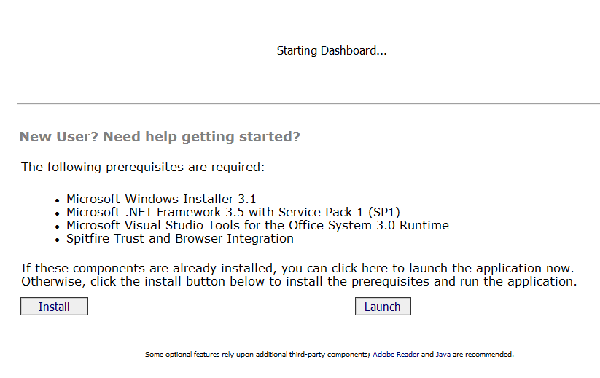

- Click the button to ensure that your workstation has the prerequisites required. sfPMS will launch afterward.
Note:
If you encounter a problem when accessing or using the Spitfire Plan Room, check first with your own IT department or help desk. The problem may be caused by something on your workstation.
If IT can’t fix the problem, contact the help desk at ____________________ and explain the nature of your problem in detail.

To Log In to sfPMS
- When you launch sfPMS, the login screen appears:
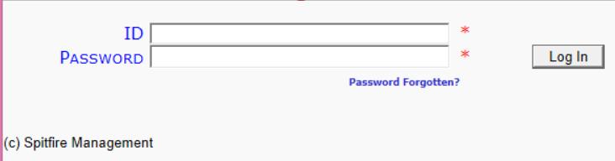
If you can’t remember your password, click this link.
Tip
If you get the message “Check your credentials…” it means you typed in an invalid ID or Password. Try again.
- Type the ID in the ID field and the password in the Password field then click .
The Plan Room Dashboard will appear:
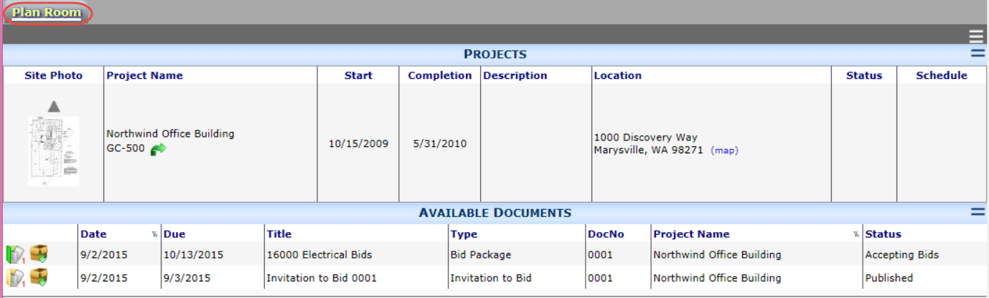

Note: if you have access to both the Home Dashboard and Plan Room Dashboard, the Home Dashboard will appear instead. You will need to select the tab to go to the Plan Room.

To Select a Project
You may have access to more than one project in the Plan Room. All accessible projects are listed at the top of the dashboard.
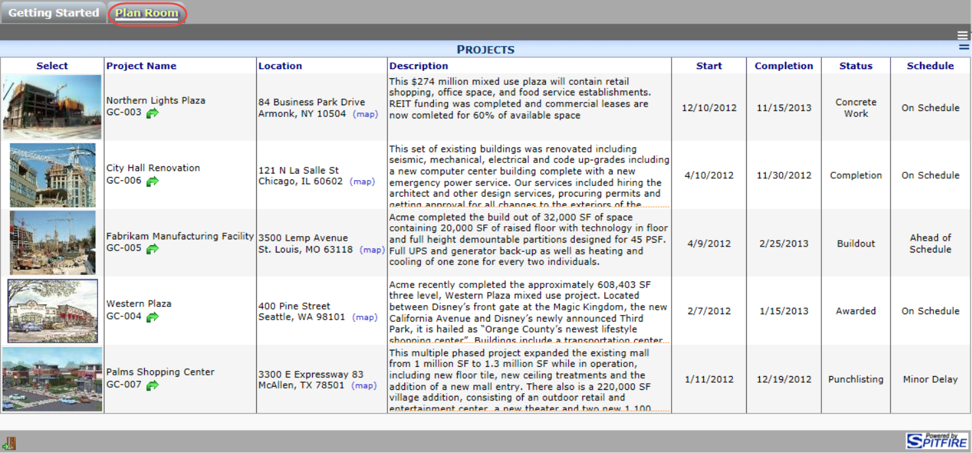

- Click on the photo of the project you want to select
-or-
Click on the Project Name of the project you want to select.
The selected project will remain at the top and available documents for that project will be listed below it, for example:
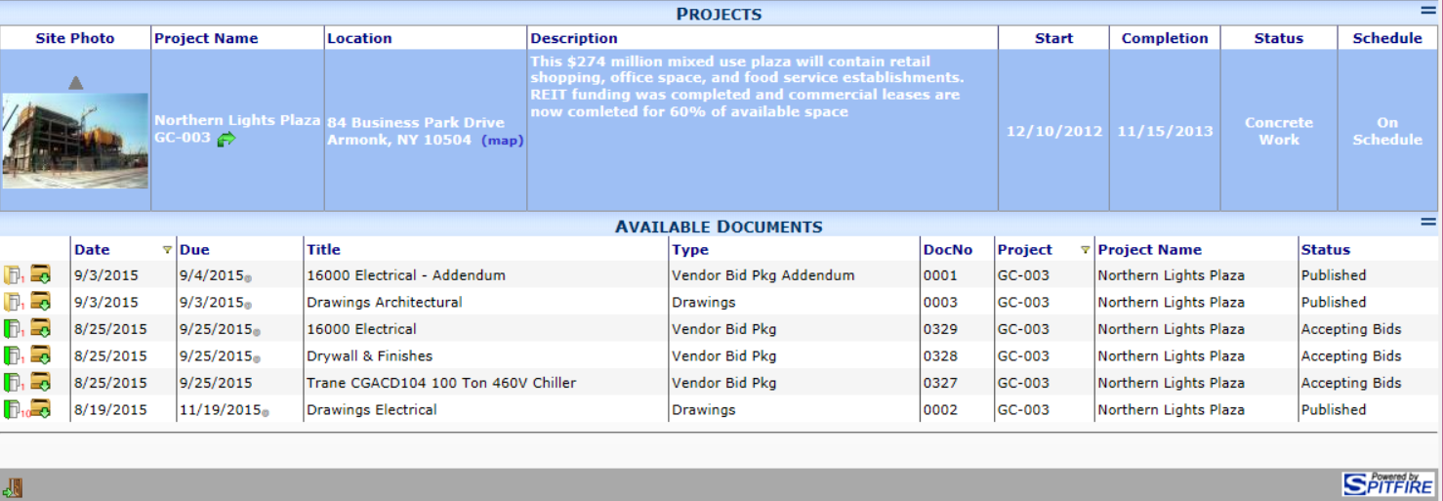

- To return to the Project List, click above the photo.

To Open a Document
- Click on the row with the document you wish to open.
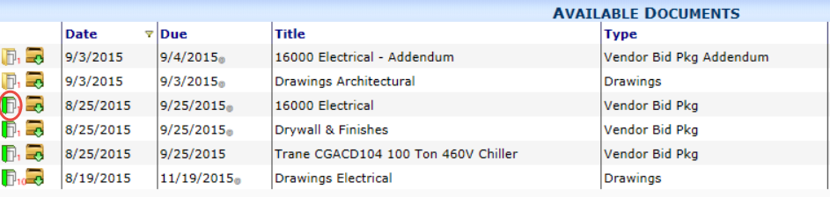
The document will open.
Note: Unless you have been given specific permissions, the document will be read-only and you will not be able to make any changes to it.
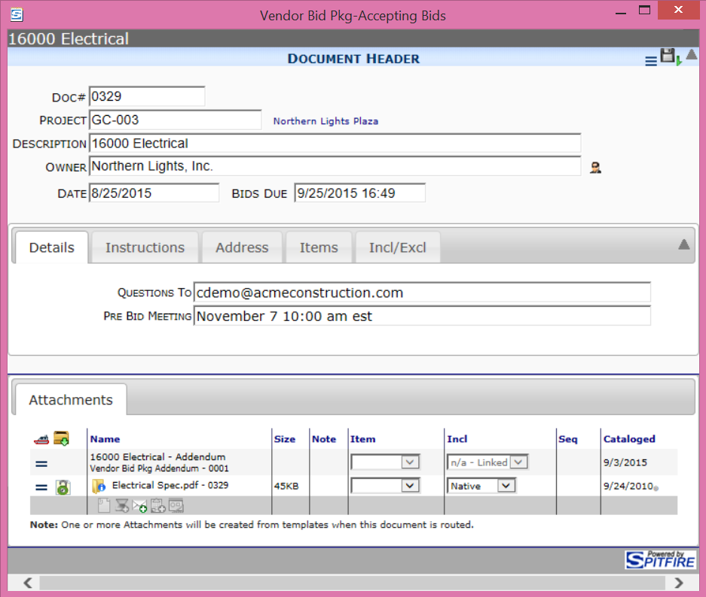
All attached files are listed in the Attachments tab.

To Download Files to Your Computer
You can download all attached files onto your computer. The download package icon appears both on the Plan Room document list and on a document’s Attachments tab. The download function creates a compressed .zip file.
- Click either from the document list or from an open document’s Attachments tab:
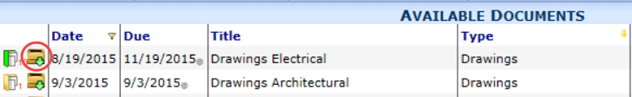
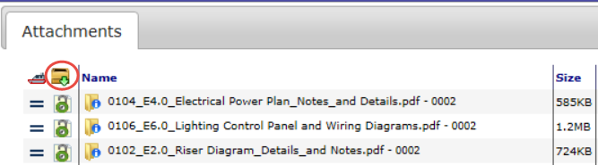
A dialog box will appear.
  - Select to see the folders within the .zip file saved on a default location on your computer/network. You can open each folder to find files.
  - Select to indicate a different location for the .zip file.

To Export Files to Your Computer
You may be able to export one or all of a document’s attached files onto your computer. When available, the export icon appears on a document’s Attachments tab. The export function allows greater control to download all, some, or just one file. The export tool also downloads each file individually (no compression or .zip file is involved) and can be restarted to pick up where it left off. For this reason, the export function may be a better choice on slow or unreliable connections.
- Click on the Attachments tab:
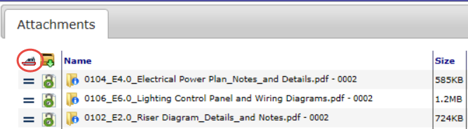
The Export Files window will open:
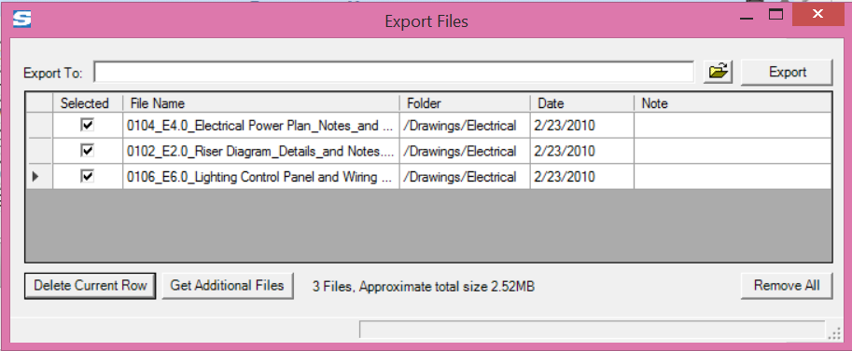
- In the Export To: field, indicate where you want to place your copy of the files. You can also click to browse for a location.
Note: if you indicate a location that does not yet exist, you will be asked if you want to create it.
You can uncheck the files you don’t want to download.
- Click the button. When the export is complete, a message box will so indicate.
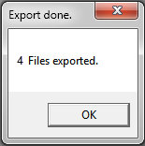
Note: the files remain on the list until you click the button. Therefore, if something (including you) interrupts the export, the files remain to be exported at a later time.
- Click to close the Export Files window.

To Respond to a Bid Package
- Open a Bid Package document.
- After reading through the Bid Package document, click the link on the Instructions tab:
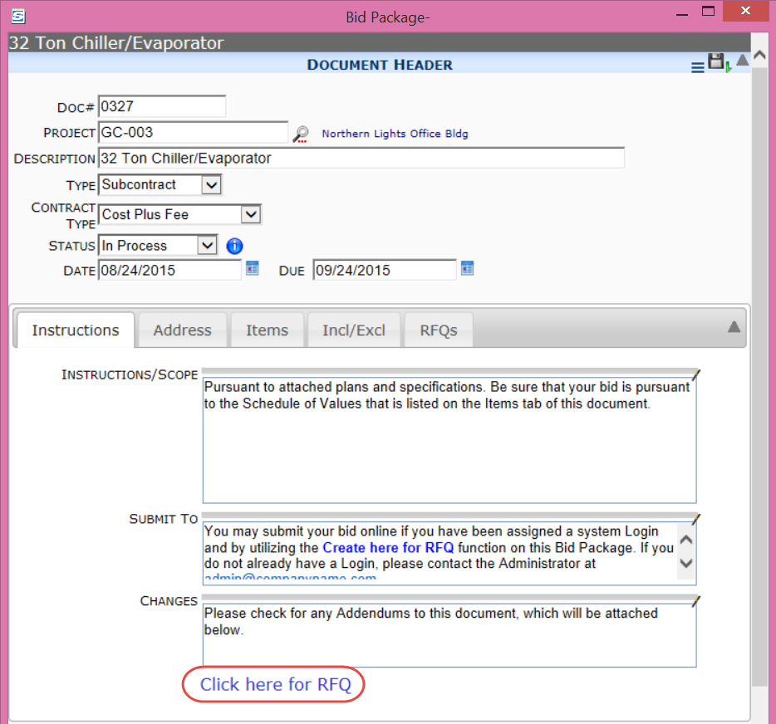
A newly created RFQ document will open. This RFQ document will have the attached files from the Bid Package and will list the Bid Package Items (on the Items tab). In addition, your company will appear on the Vendor field and your name will appear on the Vendor Submitter field.
Tip
If you do not see the Click here for RFQ link or it does not work, you mostly likely have not been given the proper permission to create the RFQ.
- Go to the Items tab to enter your information.
- Enter Quantity and Rate (if appropriate) and the Amount will be calculated or just enter a Net Amount:
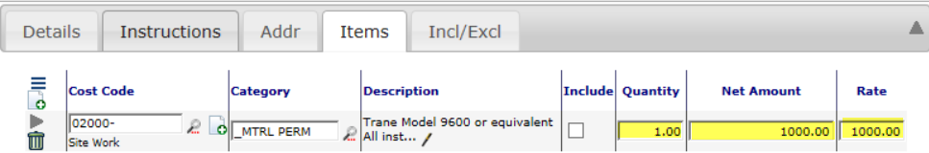
- After entering all your information, but before closing the RFQ window, go to the Route Detail tab and click on your route row.
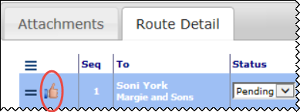
- You can then click to close the RFQ window.
Note: You can actually save (), close the RFQ window and later reopen it again, before routing the document.
- To reopen the RFQ window from the Plan Room Dashboard, open the Bid Package document again from the Plan Room and click the Click here for RFQ link. When an RFQ document already exists, this link will reopen the RFQ document.

